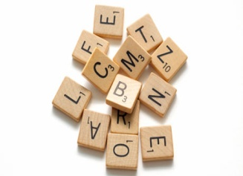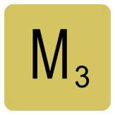ONTREAL SCRABBLE TOURNAMENT
36th Annual!
MAY 27-28, 2017
Where: Cote St Luc Aquatic Centre (not in the pool!)
5794 Avenue Parkhaven

Format: Modified Swiss and King-of-the-Hill
OWL and Collins. 5 points per word penalty in Collins.
Entry Fee: Division A: $80 (CAN)
Division B: $70 (CAN)
Division C: $70 (CAN)
Collins Division $80 (CAN)
To register please contact
Bernard Gotlieb
514-484-0824
5770 Hudson,
Cote St Luc, Quebec
H4W 2K6

or Sary at skaranofsky@jpps.ca

You can mail payment by cheque to Bernard or by Interac to Sary.
Eight Games begin Saturday at 9:15am and 6 games on Sunday beginning at 9am.
We provide lots of snacks on Saturday, and a wonderful lunch on Sunday.

