**************************************************************************************************SWILLLNS 2016
Southwest International LLL-Note Special

18-game NASPA-rated event Directed by Dave Wiegand
**************************************************************************************************
WHEN: SATURDAY & SUNDAY, JUNE 11th & 12th, 2016
Day 1: 24 players, split-half round-robin; Day 2: 4-game RR, then 1-4, 1-3, 1-2
Fri: 9:00 Walk to Sand Canyon (photo below; about a 3/4-mile walk each way from tourney site; 1-hour round trip)
Sat: 9:00 Sign-in, pairings, etc.
9:30 Rounds 1-3
12:30 Lunch provided
1:00 Rounds 4-8
6:00 Dinner provided
7:00 Rounds 9-11
Sun: 9:00 Rounds 12-15
1:00 Lunch provided
1:30 Rounds 16-18 (Gibsonization if needed.)
4:30 Awards: 1st: $1000 (prizes based on 24 paid registrants)
2nd: $500, 3rd: $400, 4th: $300; High finish <1700: $200
5:30 Optional dinner at The Range Cafe in Bernalillo (20 minutes north)
Mon: 9:00 Walk to Sand Canyon
WHERE: Pamina Deutsch & Mike Baron’s place at 696 Mission Valley Road, in Corrales, New Mexico, 87048, about 23 miles from the Albuquerque airport (30 minutes). See info on lodging (some great B&Bs in Corrales).
FEE: Three L-Notes ($150). To register, send check payable to Mike Baron at P.O. Box 2848, Corrales, NM 87048. WILL BE LIMITED TO FIRST 24 WHO PRE-REGISTER, based on postmark. (Checks will not be cashed until 6/1/16.) A list of Alternates (registrants #25 and up) will be contacted in the event one or more of the first 24 needs to cancel. Include your email address and phone.
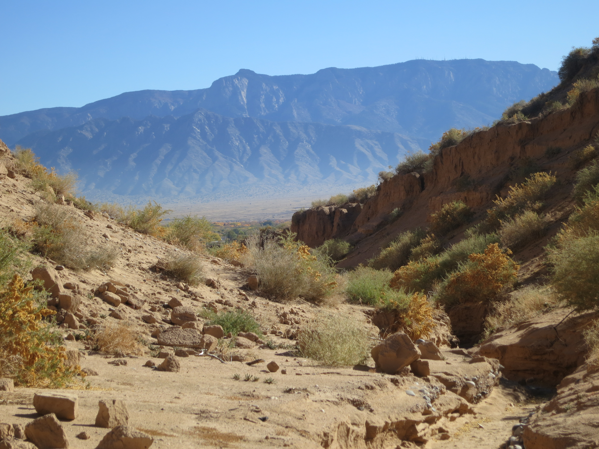
Sand Canyon © 2014 Michael Baron & Lightning

WHY: To enjoy the camaraderie, catch a phenomenal view of the Rocky Mountains, eat great food, and gear up for NSC ’16. Consider extending your weekend to include a hike(s) to Sand Canyon on Friday and/or Monday mornings, luxuriate in Santa Fe (50 minutes north of Corrales), ride the world’s longest tram ride (25 minutes east of Corrales), see a variety of Indian pueblos (including Acoma-Sky City, the longest continuously occupied residence in the US, about an hour west). Questions? Email us at: mbaron1949@gmail.com or pdeutsch@unm.edu.

The following prices were quoted in December 2014 and may change without notice. (Rates to be researched and posted at a future date.) Best to call and confirm in advance.

TRANSPORTATION
23 miles (about 30 minutes) from Albuquerque Airport to tourney site.
Sunport Shuttle (505-883-4966)
About $40 one-way, $70 round-trip ($7 each additional passenger each way).

LODGING
Lodging rates (as of 12/2015) exclude taxes. If you use Mapquest or Google Maps, or wish to explore other area lodging, use zip code 87048 for Corrales, or 87124 for Rio Rancho. Our location can also be seen by going to: http://www.milomedia.net/~michaelb/home/

Corrales Bed and Breakfasts book now before June wedding parties! (from 0.2 to 4 miles away).
Chocolate Turtle 1098 W. Meadowlark Ln. 877-298-1800 $129-159 innkeeper@choclateturtlebb.com
505-898-1800 www.chocolateturtlebb.com
$566/night for all four rooms
20% off mention Scrabble
Nora Dixon Place 312 Dixon Rd. 888-667-2349 $109-129 noradixon@comcast.net
505-898-3226 www.noradixon.com
10% off mention Scrabble
Sandhill Crane 389 Camino Hermosa 800-375-2445 $109- innkeeper@sandhillcranebandb.com
505-898-2445 $160/ste. www.sandhillcranebandb.com
for four 10% off mention Scrabble
in “Comments” section if
registering online.
Hotels
Single rates noted
ABQ = Albuquerque, about 20 min. drive to house.
RR = Rio Rancho, about 10-15 min. drive to house.

Staybridge Suites, 5817 Signal Ave NE, ABQ 877-673-7208 www.staybridge.com/albuquerquen
Albuquerque North 505-266-7829 staybridgefd@gmail.com
Double: $79.99 -> Mention” ScrabbleTournament Group”
Quad: $89.99-> for these special rates.
Free hot breakfasts, Wi-Fi
24/7 indoor pool & jaccuzzi
Extended Stay Deluxe 2221 Rio Rancho Blvd SE, RR 800-398-7829 $65 www.extendedstayhotel.com 505-892-7900 ABR@extendedstay.com
Comfort Inn 4801 High Resort Blvd., RR 866-892-5998 $100 www.comfortinn.com/hotel/nm144
505-892-5998 AAA, AARP, etc. discounts
Inn at Rio Rancho 1465 Rio Rancho Blvd., RR 800-658-9558 $80 mention Scrabble for this rate
www.inatriorancho.com
505-892-1700 AAA, AARP, etc. discounts
Days Inn of RR 4200 Crestview Dr., RR 800-329-7466 $65 www.daysinnrio.com
505-892-8800 AAA, AARP, etc. discounts
Motel 6 (Albuq. North) 8510 Pan American Fwy, ABQ 800-4MOTEL6 $45 7-days: $249
505-821-1472 www.motel6.com

